Grades 3-6 "If You Were the Historian" Korean War Inquiry

What If You Were

the Historian?

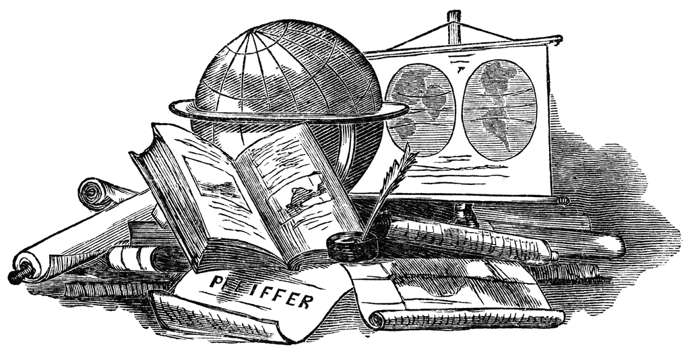

https://creativecommons.org/licenses/by/3.0/

**Memory Bank and Primary Source Inquiry Activity**

Supporting Questions

1. What do these two primary source documents reveal about this historical event or topic?
2. How can you corroborate or contradict this with an additional primary source document from the archival materials?

Grades 3-6 "If You Were the Historian" Korean War Inquiry

|  |  |
| --- | --- |
| What If You Were the Historian? | |
| C3 Framework Indicator | **D2. His.6.3-5.** Describe how people’s perspectives shaped the historical sources they created.  **D2.His.10.3-5.** Compare information provided by different historical sources about the past. |
| Staging the Compelling Question | Teachers will have students watch the first 35 seconds of the awareness test video and individually record their telling of the event in the video. Next, rewatch the entire video as a class and lead a whole-class discussion of the variations of historical telling based on perspective and viewpoint. Introduce the concept of evaluating historical documents for perspective during this discussion. The concept of corroborating or contradicting documents and sources with each other should also be introduced to students in this staging activity. |

|  |  |
| --- | --- |
| **Supporting Question 1** | **Supporting Question 2** |
| What do these two primary source documents say about this historical event or topic? | How can you corroborate or contradict this with an additional primary source document from the archival materials? |
| **Formative  Performance Task** | **Formative  Performance Task** |
| Using the graphic organizer in Appendix A, identify the narratives and facts shared by these primary source documents about the racism experienced by Korean War soldiers. | Using the Korean War Veterans Digital Memorial Project, corroborate or contradict the information shared in the featured sources of Supporting Question 1. Use the graphic organizer in Appendix A to help organize your thoughts. |
| **Featured Sources** | **Featured Sources** |
| **Source A:** Oral history, John Saxton  **Source B:** Oral history,Dottie Harris | **Source A:** Link toKorean War Memorial Digital Archives  **Source B:** Link toInteractive Memory Bank |

|  |  |
| --- | --- |
| Summative Performance Task | **ARGUMENT** Construct an argument that evaluates the primary source documents to create a one-paragraph summary of the topic or event. |
| **EXTENSION** Students can further explore the memory bank and primary source documents and discuss with a partner the strengths and weaknesses of genres of primary source information in order to explore the question, “How do we know what *really* happened in history?” |

|  |
| --- |
| **Overview of Memory Bank Exploration Activity** |

To explore the memory bank, teachers and students will watch two to three video clips on a common topic or event and then explore the archives in order to find documents that corroborate or contradict ideas and events shared in the oral history clip. Appendix A is an organizational framework for this inquiry-driven activity. The memory bank can be retrieved at <https://koreanwarlegacy.org/chapters/> and additional archival material can be found at <http://www.kwvdm.org/collection.php?p=artifact>.

1. In order to use the document set provided here as one possible variation, students should watch the two videos related to the racism experienced by Korean War soldiers, noting the experiences and facts shared in each oral history. These two oral histories have some corroborating and some contradictory ideas and perspectives.
2. Students will then explore the online archival database to find materials that corroborate or contradict these narratives. The graphic organizer provided in Appendix A is designed to help students in this process.

This activity can be altered to allow for greater flexibility in terms of topic or event, in order to meet the content requirements or technological resources available. For example, teachers could select a particular topic or event for students to explore, or students could explore the memory bank to select and then research a topic that interests them, as outlined in the following two steps.

1. In a student-driven activity, teachers should encourage students to navigate the oral history memory bank independently or in small groups, using key terms they find interesting. The memory bank has been coded for easy searches that allow students to identify common topics or events, and includes a list of tags for possible areas of exploration.
2. Students then search through the digital archive of primary sources for documents, photos, or artifacts that help them build a greater understanding of this topic, seeking to corroborate or contradict their findings from the oral history clips.

|  |
| --- |
| **Staging the Compelling Question** |

To stage the activity, teachers may prompt students with the Awareness Test video. Teachers should show students the first 35 seconds of the video, then pause it and ask students to spend a few minutes writing down their retelling of the event in the video. When students are finished writing, teachers should replay the entire video for students to view together as a class.

After the class views the entire video, teachers will want to lead a class discussion on the variations of historical tellings based on perspective and viewpoint, introducing the concept of evaluating historical documents for perspective through the variety of perspectives provided by students’ individual re-tellings of the video. Students' re-tellings of the events in the video will vary from individual to individual, providing a starting point for this discussion.

This class discussion should include:

* An introduction to the idea of *corroboration* as a tool historians use to gather the best information about historical events and the experiences of people who lived through them.
* An introduction to the idea that our *perspective* is changed by what we can actually see (as in the case of the video) as well as the era and our own, or the participants’, nation of origin, belief system, and historical perspective. Historical documents almost always present some perspectives more thoroughly and/or favorably than others.

|  |
| --- |
| **Summative Performance Task** |

At this point in the inquiry, students have examined a variety of primary sources on a topic of interest and attempted to find corroborating and/or conflicting evidence in documents discovered while searching archival material. In this summative performance task, students should evaluate the evidence they have gathered and engage in writing a paragraph that summarizes the event or topic. The topic provided was racism as experienced by soldiers in the Korean War.

Students should be able to demonstrate the breadth of their understanding and their ability to use evidence from multiple sources to support their claims. In this task, students construct an evidence-based evaluation using multiple sources, and historical thinking and evaluative skills to build an interpretation of an event or topic from history.

As an extension, students may dig deeper into the digital archives to explore the question, “How do we know what *really* happened in history?” This extension activity asks students to evaluate the strengths and limitations of different types of historical primary source documents. Scaffolds and examples of this can be found in Appendix C.

Students’ answers to this extension question will vary. Some possible answers include:

* Historians must corroborate information using a variety of sources in order to know what really happened in history.
* We must consider the voices that have been omitted from historical documents in order to understand what really happened in history; these voices include those of women, people of color, and children.
* We must select the right sources for our purpose and carefully evaluate the point of view of each.
* We can’t always know what really happened in history, but historians develop theories based on the best evidence available.

NOTE: This inquiry is expected to take four to five 30-minute class periods. The inquiry time frame could expand if teachers think their students need additional instructional experiences (i.e., supporting questions, formative performance tasks, and featured sources). Teachers are encouraged to adapt the inquiries​ in order to meet the requirements and interests of their particular students. Resources can also be modified as necessary to meet individualized education programs (IEPs) or Section 504 plans for students with disabilities.

|  |  |
| --- | --- |
| Staging the Compelling Question | |
| Featured Source | **Source A:** Video, *Awareness Test*, highlighting the fallibility of first-hand, eye-witness accounts, accessible at <https://www.youtube.com/watch?v=oSQJP40PcGI>, posted on YouTube by rickybruce1 on March 11, 2008 |



Retrieved from: https://www.youtube.com/watch?v=oSQJP40PcGI

|  |  |
| --- | --- |
| Supporting Question 1 | |
| Featured Source | **Source A:** Oral history interview with John E. Saxton, an African American who served in the Army during the Korean War, Korean War Legacy Project, accessible at <https://koreanwarlegacy.org/interviews/john-e-saxton/> |

John Saxton was born in 1929 in Kearneysville, West Virginia. His father fought in WWI and suffered lifelong effects as a result of being gassed in the War. Two of John’s brothers served in WWII. Two of John’s other brothers served in Korea. As it was difficult to find work in his town, John enlisted in the army in 1949. John did basic training at Fort Dix and was sent to Fort Hood to train for armored artillery battalion. He was assigned to the Third Infantry Division and participated in many battles in Korea, including the Pusan Perimeter and Chosin Lakes.

John Saxton recounts how a commander of the X Corps held African American troops in Korea in low regard based on his belief that African American soldiers had performed poorly during a WWII campaign in Italy.

Visit the Korean War Legacy Foundation website linked below to hear John tell his story about carry over racism from WWII.

# Retrieved from: <https://koreanwarlegacy.org/interviews/john-e-saxton/>

Used with permission from the Korean War Legacy Project

|  |  |
| --- | --- |
| Supporting Question 1 | |
| Featured Source | **Source B** Oral history interview with Dottie Harris, an veteran who witnessed racism while serving in the Air Force from 1951-1952, accessible at https://koreanwarlegacy.org/interviews/dottie-harris/ |

Dottie Harris was born in Verona, Pennsylvania in October of 1931. She was living with her grandparents and working as a cashier at Krogers when she decided to enlist into the United States Air Force on January 31, 1951 in Pittsburgh, Pennsylvania. She was stationed at James Connally Air Force Base in Waco, Texas in May of 1951. Before she was discharged in July of 1952 she served as an Airman 1st Class sergeant. She specialized as an officer in personnel Flying Training Air Force.

The air force was the first branch of the service to be fully integrated. Dottie Harris tells of a specific incident where she witnessed African American men in service being called names and she was too because she sat and had dinner near them. Some white men in the service thought that there should not be any blacks in the uniform, and no women in uniform either.

Visit the Korean War Legacy Foundation website linked below to hear Dottie tell her story about Racism in the Air Force.

Retrieved from: https://koreanwarlegacy.org/interviews/dottie-harris/

Used with permission from the Korean War Legacy Project

|  |
| --- |
| Appendix A: Comparing and Corroborating Primary Source Documents (Organizer) |

Topic or event: ___________________________________________

|  |  |
| --- | --- |
| Perspective of oral history #1: | Perspective of oral history #2: |
| What corroborating or contradicting evidence can be found in the archives? | |
| What really happened? How do you know? Use evidence from the primary sources to support your claim. | |

|  |
| --- |
| Appendix B: Viewing Guide for Oral History Videos (Scaffolding Tool) |

**Oral histories are a tool used to document people’s experiences. Listen to one of the veterans talking about his or her life in the oral histories provided, and reflect on these questions as you listen.**

Veteran’s Name: _______________________________________

Military Service Start Year: _______________________________

Millitary Service End Year: _______________________________

|  |  |
| --- | --- |
| What are two facts you learned about history from listening to this oral history?  1.    2. | What surprised you most about this story? What did you find most interesting? Why? |
| What are two facts you learned about this person and their perspective from listening to this oral history?  1.    2. | What remaining questions do you have about the historical events discussed or the people who experienced them? |

|  |
| --- |
| Appendix C: Tools for Exploring Strengths and Weaknesses of Primary Sources |
| “Strengths and Weaknesses of Primary Historical Sources” (excerpt), Smithsonian Institution, retrieved from https://library.si.edu |

Macintosh HD:Users:MarilynIsaacks:Desktop:images.pdf

Macintosh HD:Users:MarilynIsaacks:Desktop:oral history.pdf

Macintosh HD:Users:MarilynIsaacks:Desktop:documents.pdf